DripSense: An IoT-based system for detecting and alerting hidden water leakages
Dr.D.Manju, Assistant Professor, Department of CSE-(CyS,DS) and AI&DS, Hyderabad, India.
S.R.Anand Kumar, Professor of Practice, Department of CSE-(CyS,DS) and AI&DS, Hyderabad, India.
Panthangi Venkateswara Rao, Assistant Professor, Department of CSE-(CyS,DS) and AI&DS, Hyderabad, India.

Abstract
The present invention relates to an intelligent IoT-based system for detecting and alerting hidden water leakages in pipelines. The system comprises a sensing unit equipped with ultrasonic and flow sensors to monitor water flow characteristics. A control unit with an ESP32 microcontroller processes sensor data and communicates wirelessly via an integrated Wi-Fi module. Data is transmitted to a web-based dashboard interface, which provides real-time system status, leakage alerts, flow analytics, and historical usage records. The system operates through a service cycle including leak detection, notification, and action to prevent water damage. The invention further provides a method for continuous monitoring, data processing, wireless communication, and real-time user notification, enabling proactive water management and damage prevention.

Introduction
The present invention relates in general to systems for fluid management and conservation, particularly to an Internet of Things (IoT)-based water leakage detection and alert system designed for real-time monitoring of plumbing networks in residential, commercial, and institutional settings. The invention integrates ultrasonic or flow sensors with wireless microcontrollers to detect abnormal water flow patterns and communicate timely alerts via a web-based user interface.
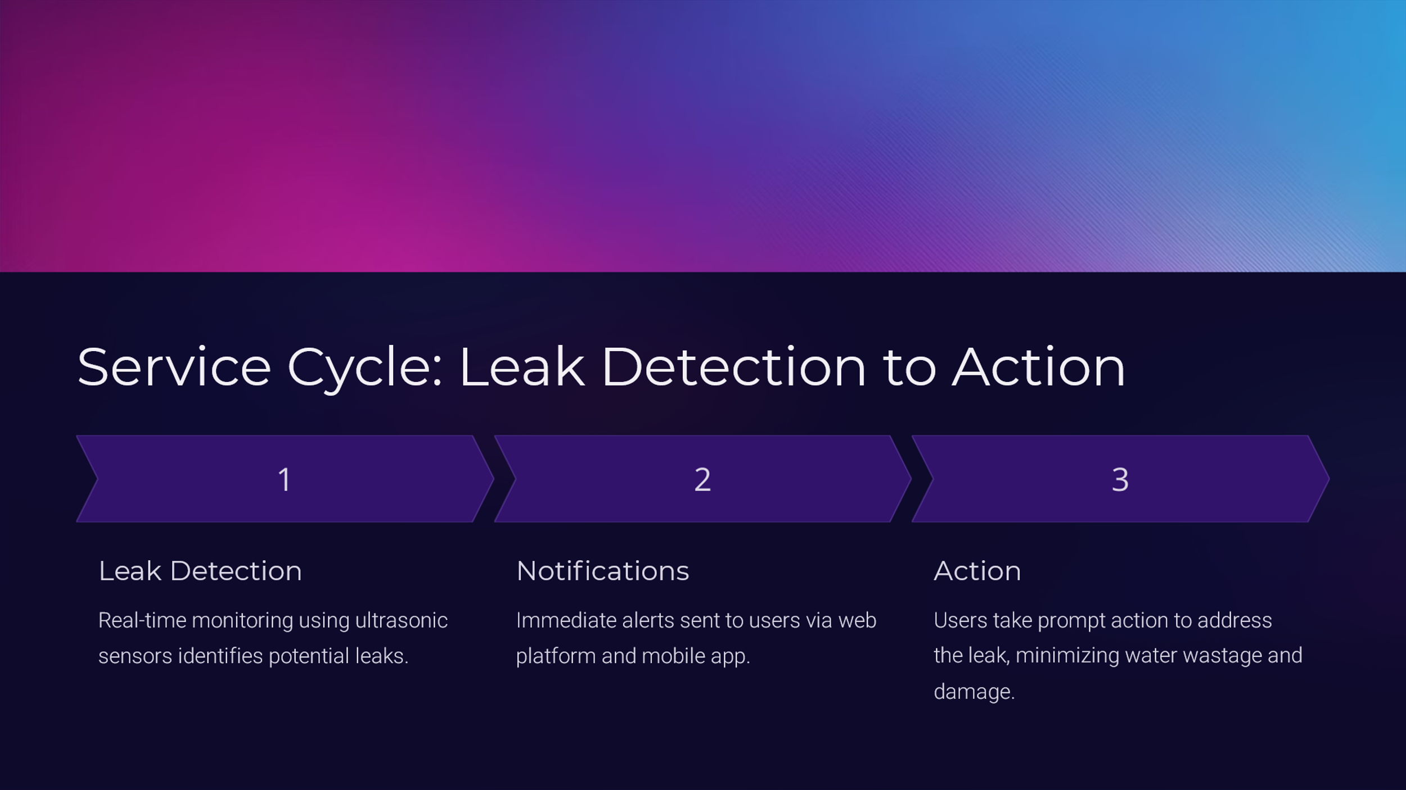
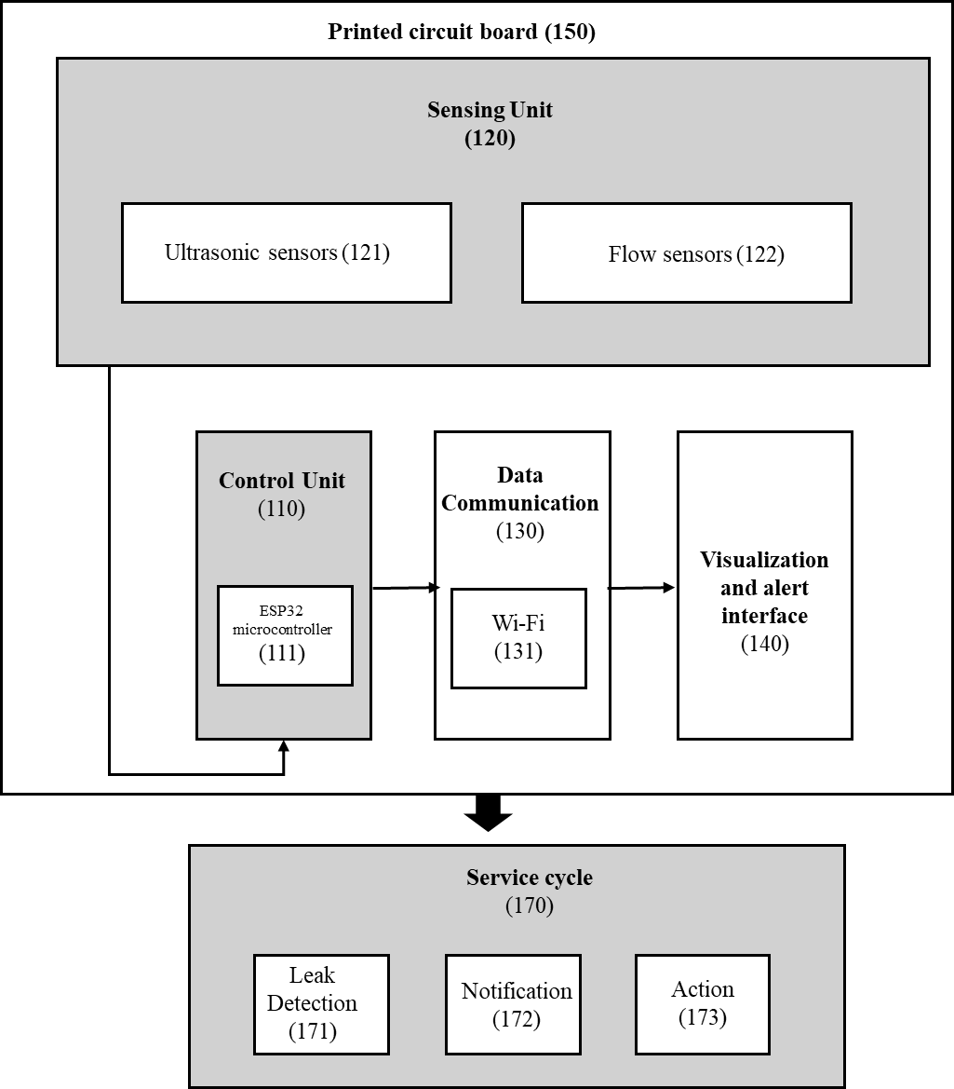
Figure 1 Model Workflow

Literature Review
Water leakage detection has been traditionally addressed using manual inspection and conventional monitoring methods such as flow meters and periodic pipeline checks. However, these methods are inefficient, labor-intensive, and often fail to detect micro-leakages hidden within walls, underground pipelines, or concealed joints.
Existing smart water meters and electronic monitoring systems have attempted to address this problem by integrating ultrasonic, acoustic, or pressure-based monitoring techniques. While effective to some extent, these systems face several drawbacks:
- High cost and complexity, making them unsuitable for residential or small-scale deployment.
- Limited distributed sensing capability, leading to poor localization of leaks.
- Inability to detect slow or early-stage leaks.
- Lack of user-friendly interfaces and real-time alert mechanisms.
Recent research emphasizes the need for IoT-based solutions that integrate sensors, wireless communication, and cloud-based analytics. Studies have shown that IoT-driven systems can improve scalability, provide instant notifications, and enable predictive maintenance through data analytics. However, most existing models are either designed for large municipal setups or lack modularity and adaptability for household applications.
The present invention, DripSense, builds upon these prior efforts and introduces a cost-effective, scalable, and intelligent IoT-based approach that bridges the gap between existing high-cost industrial systems and ineffective manual inspections

Methodology
The DripSense system is designed as a distributed IoT architecture for detecting and alerting hidden water leakages.

Sensing Unit (120):

Equipped with ultrasonic and flow sensors to monitor real-time water flow characteristics such as pressure, velocity, and volume. These sensors detect irregular flow patterns indicative of leakage.

Control Unit (110):

The ESP32 microcontroller serves as the primary processor and communication unit. It compares flow data against predefined thresholds. For distributed setups, an Arduino Uno preprocesses sensor signals to filter noise and enhance accuracy.

Data Communication (130):

The ESP32’s Wi-Fi module transmits processed data to the cloud for real-time analysis.

Visualization & Alert Interface (140):

A Streamlit-based dashboard provides visual analytics, water flow metrics, and instant alerts. Users can monitor real-time data, receive notifications, and review historical trends.

Action Phase (173):

The system can trigger an automated solenoid valve to stop water supply when leakage is detected, minimizing damage and wastage.

Hardware Integration (150):

A custom PCB integrates sensors, controllers, and communication modules into a compact, modular, and scalable unit.

This methodology ensures a closed service cycle: leak detection → notification → action.

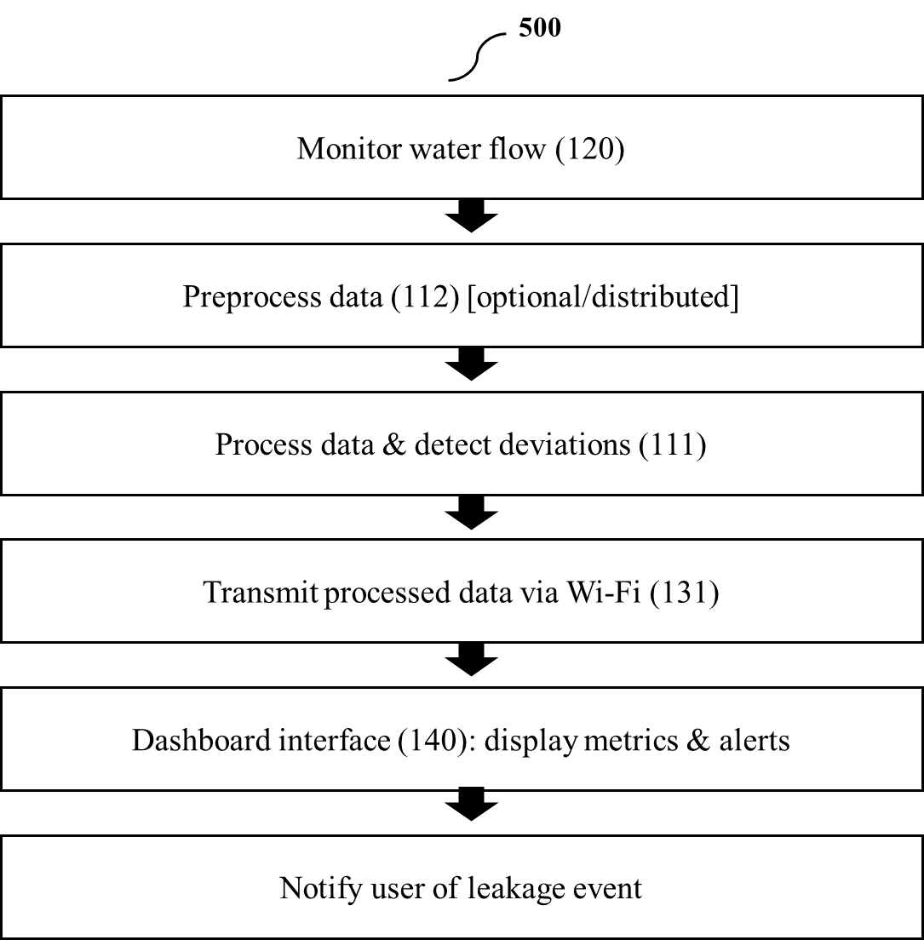

Results
The DripSense system demonstrates several practical outcomes and advantages:
- Accurate Detection: Capable of identifying both visible and hidden leakages, including slow drips that traditional methods miss.
- Real-Time Alerts: Instant notifications are generated via the dashboard, ensuring timely intervention.
- Scalability: Modular architecture supports deployment across households, commercial spaces, and municipal networks.
- Cost-Effectiveness: Compared to high-end industrial leakage systems, DripSense is affordable and suitable for small-scale users.
- User-Centric Interface: Streamlit dashboard provides intuitive visualization and analytics accessible to both technical and non-technical users.
- Preventive Action: Automated solenoid valve integration ensures immediate containment of detected leaks.
- Sustainability Impact: Conserves water, prevents structural damage, and promotes responsible resource management.
The system thus transforms leakage detection from a reactive manual process into a proactive, automated IoT-driven solution, making it a strong candidate for real-world adoption in residential and industrial applications.
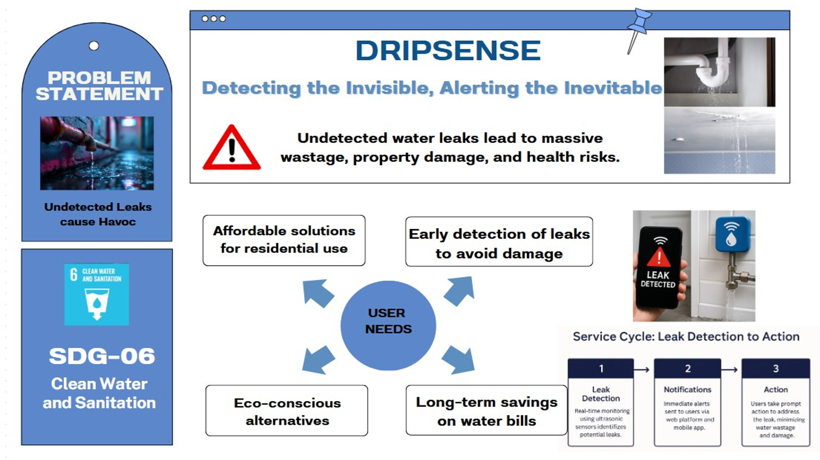
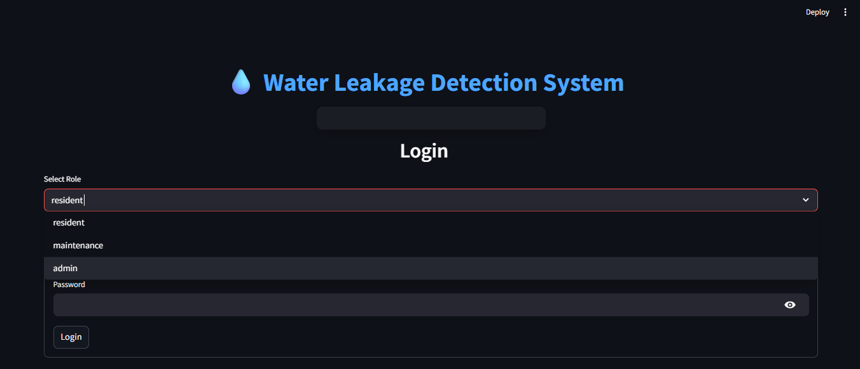
Fig-1: Login credentials page
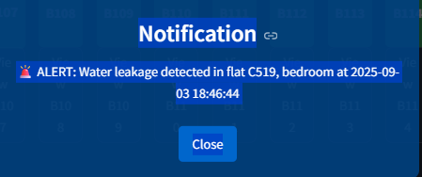
Fig-2: Pop-up Notification showing water leakage detected
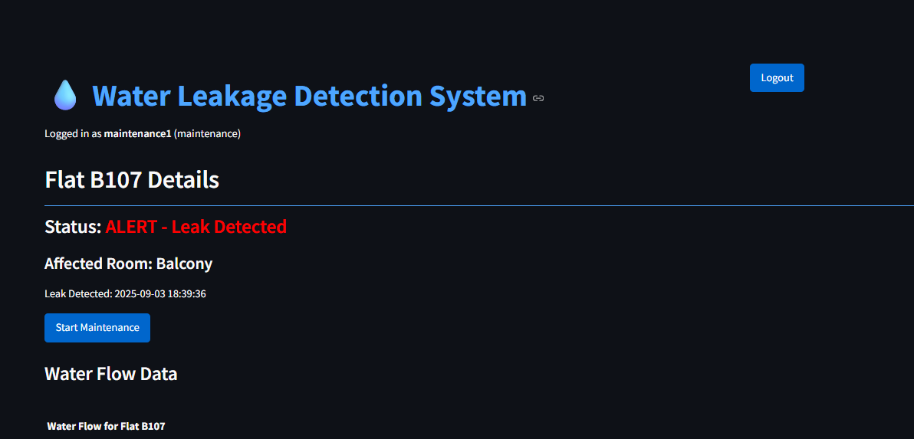
Fig-3: Showing status of particular flat
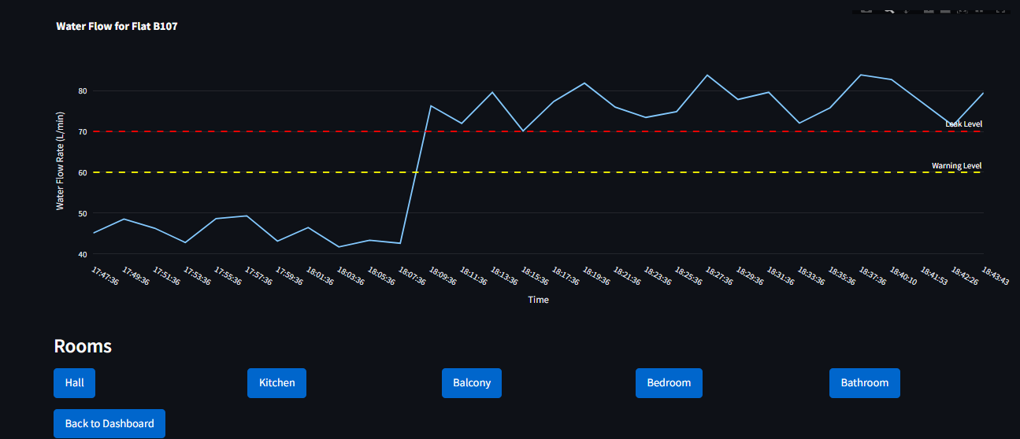
Fig-4: Water Leakage graph showing level w.r.t. time in the flat
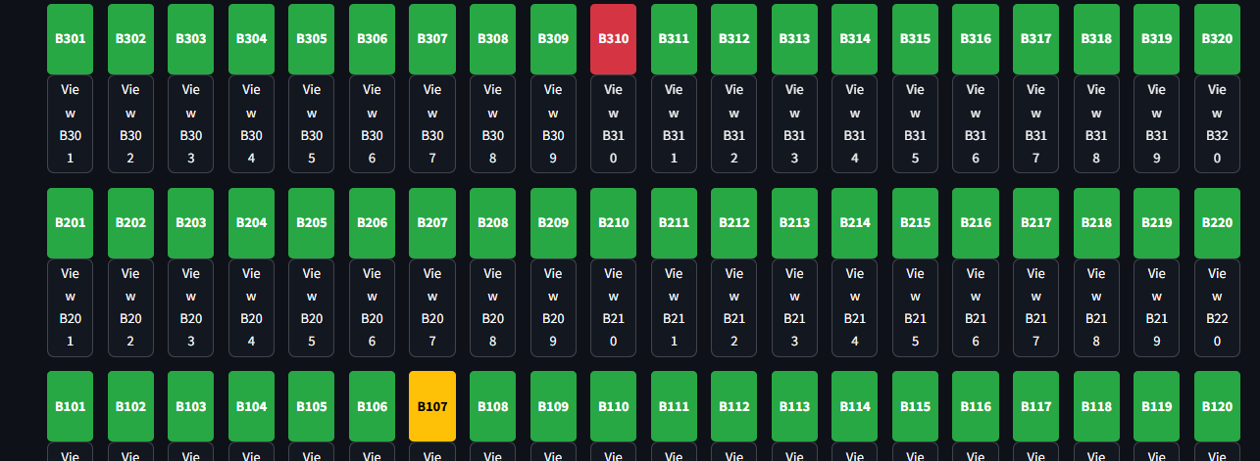
Fig-13: Dashboard showing flats with
Green => No leakage Yellow => Under Maintenance Red => Leakage detected
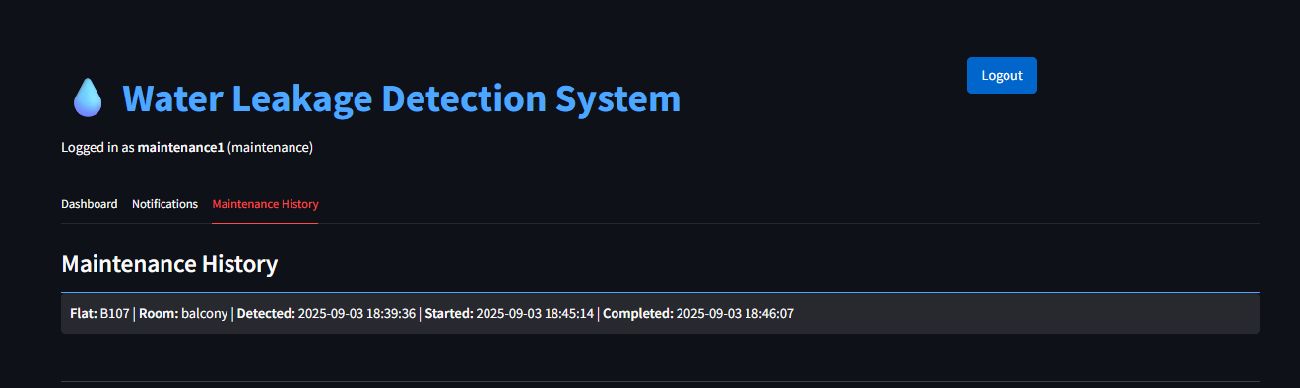
Fig-17: Maintenance history for the particular flat resident and
for the maintenance team for future reference

